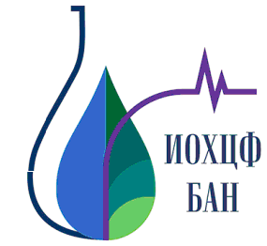
COMPARATIVE STUDY OF ALKALOID PROFILE OF THREE HYPECOUM SPECIES

Tsvetelina Doncheva¹, Nadezhda Kostova¹, Radostina Toshkovska¹, Vassil Vutov², Houcine Saadi³, Stefan Philipov¹

¹ Institute of Organic Chemistry with Centre of Phytochemistry, Bulgarian Academy of Sciences, Sofia, Bulgaria
² National Museum of Natural History, Bulgarian Academy of Sciences, Sofia, Bulgaria
³ Department of Chemistry, Faculty of Sciences, University of M’sila, Algeria

The genus Hypecoum L. (Papaveraceae) is represented by 18 species growing in the Mediterranean region, Central Asia and China. The plants are used in Tibetan medicine as an antipyretic, analgesic and anti-inflammatory remedy [1]. The plants are known for their biologically and pharmacologically active isoquinoline alkaloids, such as protopines, protoberberines, aporphines, benzophenantridines, spirobenzylisoquinolines and secoberbines [2].
Alkaloid profiles of Hypecoum pendulum L. (Algeria), Hypecoum procumbens L. (Bulgaria) and Hypecoum ponticum Velen. (Bulgaria) - an endemic species for the Balkan region, were investigated and 10 isoquinoline alkaloids were determined. The main alkaloid of tertiary alkaloid mixtures in all analyzed samples were protopine. From quaternary alkaloid mixtures of Hypecoum procumbens and Hypecoum ponticum were identified the alkaloids N-methilcanadine and N-methylstylopine. These alkaloids were found for the first time from the species Hypecoum ponticum.
One new natural alkaloid with quaternary structure was isolated from Hypecoum ponticum and its structure was determined on the basis of detailed spectroscopic analysis, including 1D and 2D NMR and EI MS.

References:

1. Willis J. C (1966) A Dictionary of the Flowering Plants and Ferns (7th ed.) Cambridge University Press, Cambridge, pp. 569.
2. Preininger V (1986) Chemotaxonomy of Papaveraceae and Fumariaceae. In: Brossi, A. (Ed.), The Alkaloids, vol. 29. Academic Press, London, pp. 1–98.

Acknowledgements

